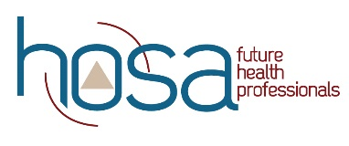
HOSA Mini: Did You Say Biotechnology

Objectives:
Upon completion of this lesson, students will have sufficient knowledge of, and be able to:
- define biotechnology.
- explore the history of biotechnology.
3. understand the impact of biotechnology on the future.
4. identify the role of biotechnology in fighting Covid-19.
5. survey available careers in the biotechnology area
6. research one career in biotechnology of interest.

Time:
- Lecture on biotechnology (20 min)
- Videos related to biotechnology (1/2 class)
- Research biotechnology careers (1/2 class)

Materials:
- ppt
- internet access
- Trifold board

Instruction:
- Share PowerPoint on Biotechnology
- Share videos from the Biotechnology Playlist
- Explore Biotechnology Careers
- Develop a Health Career Display

Assessment:
1. Completed Health Career Display

Standards:
NCHSE
1.2.2 Describe biomedical therapies as they relate to the prevention, pathology, and treatment of
disease.
• Gene testing
• Gene therapy
• Cloning
• Stem cell research

3.1.3 Analyze the impact of emerging issues on healthcare delivery systems.
• Addictions
• Bioethics
• Epidemiology
• Socioeconomics
• Technology

4.3.1 Research levels of education, credentialing requirements, and employment trends in health
professions.

4.3.2 Distinguish differences among careers within a health science pathway.
• Biotechnology research and development
• Diagnostic services
• Health informatics
• Support services
• Therapeutic services

For additional Curriculum Crosswalks see CE Useful Tools

