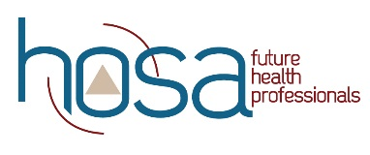
HOSA Mini Lesson: Professionalism in The Clinical Setting

Objectives:
Upon completion of this lesson, students will have sufficient knowledge of, and be able to:
- define professionalism in their own words.
- list qualities that would indicate professional behavior.
- identify what factors would make a good first impression the first day in the clinical setting.
- determine what soft skills are important in the clinical setting.
- develop a resume and personal statement.

Time:
- Ppt. on professionalism in the clinical setting. (10 min)
- Selected activities from Department of Labor Mastering Soft Skills for Workplace Success: https://www.dol.gov/sites/dolgov/files/odep/topics/youth/softskills/softskills.pdf TBD by Advisor
- Selected videos for Soft Skills to Pay the Bills.
https://www.dol.gov/agencies/odep/program-areas/individuals/youth/transition/soft-skills/videos TBD by Advisor
- HOSA guidelines rubric for resume & personal statement. (60 minutes)

Materials:
- Internet access

Instruction:
1. Complete ppt overview.
2. Selected activities from Department of Labor Mastering Soft Skill for Workplace.
2. Selected videos from Soft Skills to Pay the Bills.
3. Write a resume and personal statement. Rubric HERE.

Assessment:
- Activity completion
- Resume
- Personal Statement

Standards:
NCHSE
4.1 Personal Traits of the Health Professional
4.1.1 Identify personal traits and attitudes desirable in a career ready member of a health team.
4.1.2 Summarize professional standards as they apply to hygiene, dress, language, confidentiality and behavior.
4.4 Employability Preparation
4.4.1 Develop components of a personal portfolio.

For additional Curriculum Crosswalks see CE Useful Tools

