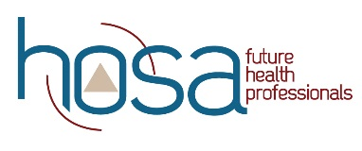
HOSA Mini Lesson: Stem Cell Transplant

Objectives:
Upon completion of this lesson, students will have sufficient knowledge of, and be able to:
- define stem cell.
- list diseases for which stem cells are effective.
- Identify what determines stem cell matches.
- describe the impact of the Tuskegee studies on the registry numbers.
- compare and contrast the role of the donor & recipient in blood stem cell transplants.
- develop a plan for the HOSA chapter to be involved in promoting registration for blood stem cell registry.

Time:
- Be The Match HOSA Curriculum – ½ class period
- Plan for promotion of registration – ½ class period

Materials:
- Internet access
- Worksheet (one copy per student)

Instruction:
- Watch fairytale ending video on Imani.
- Complete worksheet using HOSA Be The Match curriculum.
- Work in groups to establish and document the plan for promoting registration for stem cell donation using HOSA guidelines for HOSA Service Project event guidelines.

Assessment:
- Completed worksheet
- Plan for promoting registration

Standards:
NCHSE
1.1.2 Identify basic structures and describe functions of human body systems.
d. Cardiovascular
- Distinguish blood components

1.2.2 Describe biomedical therapies as they relate to the prevention, pathology, and treatment
of disease.
- Stem cell research

6.2.1 Discuss religious and cultural values as they impact healthcare.
• Ethnicity
• Gender
• Race
• Religion

For additional Curriculum Crosswalks see CE Useful Tools

