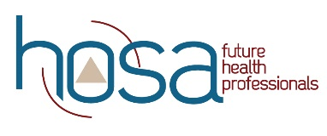
HOSA Mini Lesson: Math for Health Professions: Basic to Pharmacy

Objectives:
Upon completion of this lesson, students will have sufficient knowledge of, and be able to:
- Demonstrate conversions.
- Calculate conversions for temperatures.
- Define ratio and proportion.
- Formulate dosages.
- Solve concentration problems.
- Perform dilution problems.
- Calculate IV flow and drip rates.
- Solve alligations.

Time:
- Lecture - 1 class period
- Practice – as needed

Materials:
- PowerPoint
- Calculator

Instruction:
- Share PowerPoint on Medical Math ( 14 minute video)
- Website for blood pressure practice

Assessment:
1. Written test

Standards:
NCHSE
1.3.1 Demonstrate competency using basic math skills and mathematical conversions as they relate to healthcare.

For additional Curriculum Crosswalks see CE Useful Tools

