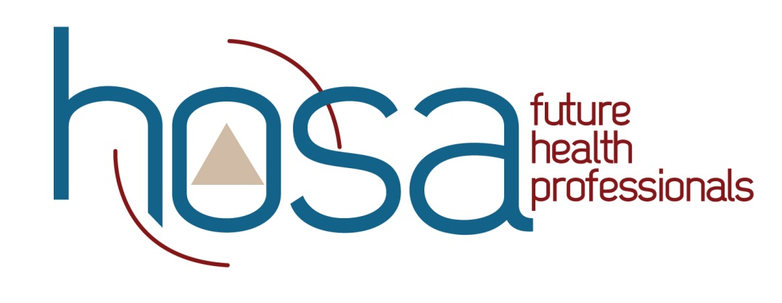
SAMPLE TREASURER’S REPORT

ABC High School

For the year ending June 30, 2015

Balance on hand, July 1, 2014 $1,253.25

Receipts
Dues $ 200.00
Car Wash $ 400.00
Contribution from ABC Medical Association $ 500.00

TOTAL RECEIPTS $1,100.00

Disbursements
National Leadership Conference $1,300.00

TOTAL DISBURSEMENTS $1,300.00

BALANCE ON HAND JULY 1, 2015 $1,053.25

