
Brainstormed Program of Work Activities
  - Brainstormed at National HOSA Washington Leadership Academy, September 2013
Social Activities
- Communication Workshop
- Bowling Social (collect toiletries or first aid items to donate to local charities)
- Leadership Workshops
- Christmas shop at nursing home
- New members party
- Mardi Gras parade for nursing home residents
- Weekend officer meetings
- State Fall Leadership Conference
- State Leadership Conference
- Ice cream & Cupcake social as a school year kickoff
- HOSA Month – HOSA Tea
- Wrap-up Party – wrap gives for needy children
- Dance, sing, play instrument in a senior facility
- Lunch social
- Walks
- Seasonal Treats at meetings (ex: in December, cookie decorate & eat)
- Root Beer Floats
- HOSA Breakfast
- Fun night @ a game sports complex
- Night out at a professional sporting event
- Dance
- Movies/Movie Night with popcorn, soft drinks
- Skiing
- Picnic
- Pool/Swimming Party
- Fall Hayrides
- Haunted Houses
- Teacher Appreciation
- CTE Week-Partner Appreciation
- Pizza Party
- Day at a theme park
- Corn maze
- Networking receptions at state conference
- Boat tours
- Historical tours
- Team building
- Summer Camp out
- Hypnotist Show
- Holiday Party
- Exercise Party (Aerobics, Yoga, Zumba, etc)
- Meet & Greet
- Bingo Nights
- Cultural feast
- Obstacle Courses
- Dinner with a HOSA chapter from another school
- Visit nursing home – do residents nails
- Get together with other CTSOs
- Game Day Activities
- Lip Syncing Competition
- Talent Show
- Field Day
- Board Game Night
- Lock-ins
- Participation in local parades
- Thanksgiving Feast
- Party for orphanage
- Beginning of the Year BBQ
- School Board Dinner
- Night at the ballpark
- Decorate holiday/Christmas trees
- Cultural potlucks
- Birthday celebrations
- Human BINGO
- Murder Mystery Party
- Ropes Course
- Class study groups
- HOSA Olympics (wheelchair races, related health competitions)

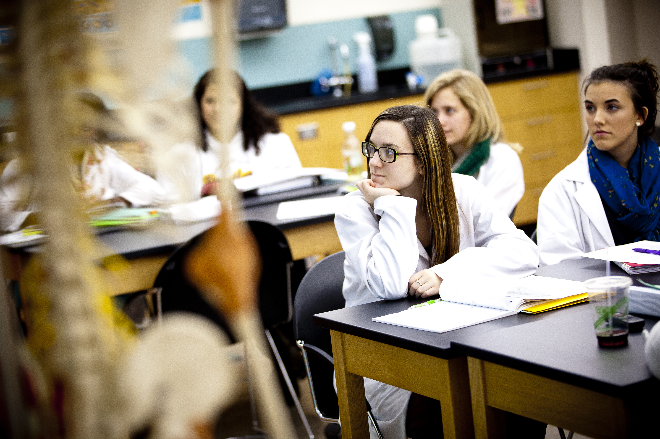

Financial Leadership Activities (Fundraising)
- Carry Groceries at local grocery store
- Blood pressure clinics
- Grants
- Pizza sales
- Candle sales
- Beg
- Spaghetti supper
- Buffalo Wild Wings
- National Service Project fundraising
- Industry sponsors
- Cookie sales
- Popcorn sales
- Healthy snack sales
- Spirit Nights at Restaurants (Chipotle, Chili’s, Canes)
- Lollipop sales
- Brochure sales
- T-shirt/Spirit item sales
- Water bottle sales
- Brisket dinner
- Krispy Kreme sales
- Students sponsors
- Collectable items
- Silent Auction Items
- Bake sales
- Meal delivery
- Tree sales
- Pictures with Santa
- Carnation sales
- Fruit sales
- Movie day at school
- Hat day at school (charge $1 or $5 for students to wear hats)
- Mixed Bag Design Sales
- 31 sales
- Bouquet of the Month
- Alumni outreach/giving program
- Partnerships with local restaurants
- First aid kit sales
- Community help for families (families make donation)
- Legislative support
- Car wash
- HOSA Bingo
- Cutlery sales
- Park cars for local festival
- Pick up trash for county (can get paid to do this)
- “Drive for your school”
- Cookie Dough Sales
- See’s Candy sales
- Jump rope for Health
- Flower Bulb Sales
- Country Meat Sales
- Parents Night Out
- Dances
- Basket Raffles
- Rada Knives
- Concession Stands
- Hot Dog Sales
- BBQ Dinner Fundraiser
- Newspaper
- Recycling Drives
- Yard Sales
- Booth at the Fair
- Booth at the fair
- Jewelry sale
- Carnival @ Elementary Schools
- Christmas Wreaths
- Cookouts
- 5K Run
- Donation Letter to medical facilities
- Penny Wars
- Jambalaya Sale
- Operation Game/Tournament at school sporting events
- Candy Sales
- Spring fling carnival
- Cookbook sales (developed by students)
- Flower sales
- Technology Recycle Drive (cell phones, printers, ink cartridges)
- Program sales at sporting events
- Change jar in the classroom
- Snack cart
- Help-a-thon (Fall and Spring)
- Silent Auction
- Virtual 5K Run
- Couch Potato 5K
- Chocolate Wonderland
- Face painting booth at fairs/homecoming
- World’s Finest Chocolate
- Country Meats
- Evil Elf Invasion
- Best Seat in the House (at basketball/football games)
- T-shirt sponsors
- Restaurant nights
- Fun Runs
- Kroger/King Soopers/Target/Smart cow percentages
- Butter Braids
- Garage sale
- First Aid kits
- Pizza Pales cards
- Encourage competition between classes for raising funds
- Workshop to learn Quicken/Quickbooks
- Guest speakers from financial institutions
- Participate in stock market games
- NEFE curriculum as supplemental resource
- Junior Achievement teaching variety of financial topics
- Chili Cook Off
- Teeth Whitenin
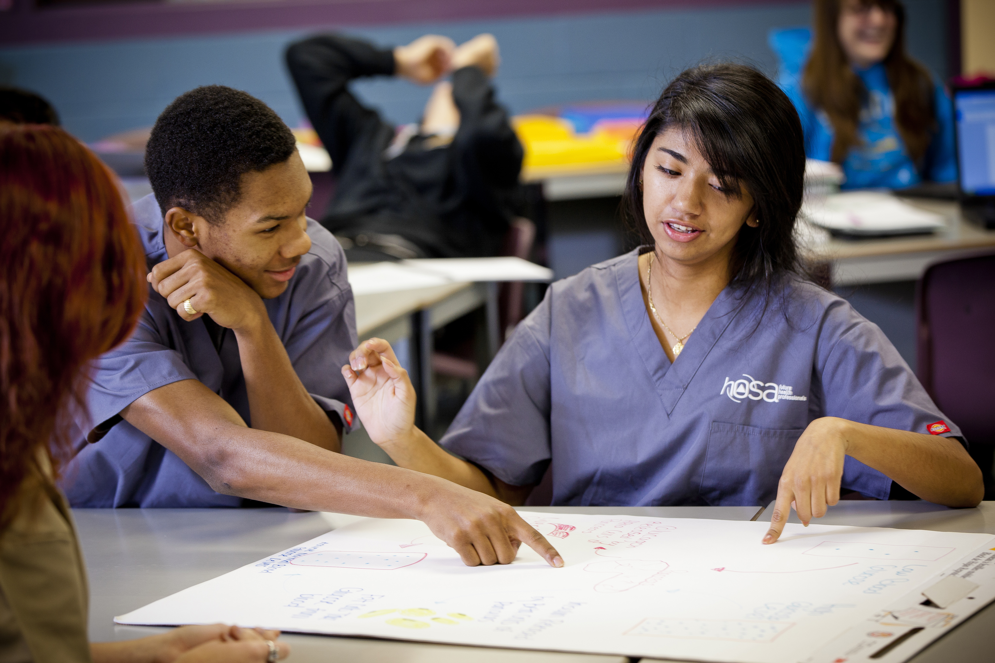
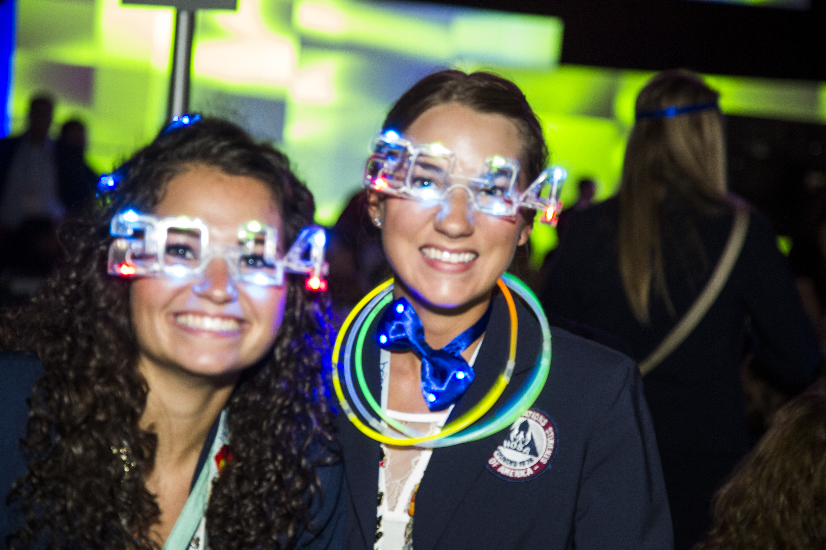
Conference Attendance
- Fall Leadership Conference
- Spring Area Competition
- State Leadership Conference
- National Leadership Conference
- Washington Leadership Activity
- CTE Day at the Capitol
- Conference Calls
- State Health Science Professional Development Conference
- Incentive Program for conference attendance
- Online Testing
- State ACTE conference – session facilitators, presenters, note takers
- National Health Science Consortium Curriculum Conference
- School Board Meetings
- Nurse Association Convention

Service Projects
- Cystic Fibrosis Foundation
- JDRF – Juvenile Diabetes Research Foundation
- Arthritis Foundation
- Alzheimer’s Association
- Leukemia/Lymphoma
- Blood Drives
- Local CERT Training
- Autism Speaks
- Local Clothes Closet
- Strides Against Breast Cancer
- Special Olympics
- Blanket Drive/Walk
- Tyler’s Hope
- Make-A-Wish
- Humane Society
- St. Jude’s
- Blood Pressure Clinics
- Type II Diabetes
- Cancer Center
- Komen Race for the Cure
- Nursing homes
- Big Brothers/Big Sisters
- Walk for sight
- Adopt a Grandparent
- Project Joy & Hope
- Community Health Fair
- MRC – Medical Reserve Corp
- 5K run & walk
- Teaching hand washing to 1st graders
- Relay for Life
- Pennies for Patients
- Trash Pick-up
- Food Bank
- Christmas Adopt-a-Family
- Canned Food drive
- Homeless shelter donations
- Penny Wars
- Talent Show with Pass the hat
- Halloween trick-or-treating for donations
- Friends for Health in Haiti
- Heart walk
- Blizzard Bags for Red Cross
- Bone Marrow match drive
- City of Hope
- Ronald McDonald
- Unite to Read
- Volunteer for child services
- Toy Drive (local foster care programs)
- Angel tree (child and senior)
- “Shop with a Cop”
- School based drive (tissues, hand sanitizer, etc.)
- Barbara James Service Award
- Awareness Months – Breast Cancer, Heart
- Linus Project
- Blood pressure screening at football games
- Hands only CPR classes
- Public Service Announcements
- Organize Fall Festival Carnival for elementary schools in the district
- Book drive for elementary schools
- Crohn’s & Colitis Foundation of America
- International Dyslexia Association
- Goodwill/Salvation Army Drives
- Health care packages (hygiene, tooth brushes, toothpaste)
- Coat drive
- Pennies for Pasta – Leukemia
- Packages for Military members abroad
- Flu Shot Service
- Clothing drive for mental facility
- Save tabs for hospital
- Casual for a Cause – teachers pay $5 to wear jeans – donations to CFF
- Used glasses for Lion’s Club
- Adopt-a-Family at Thanksgiving and Christmas
- Help-a-thon
- Water Stations at graduation ceremonies
- Vision & hearing screening for elementary and middle school students
- Teen Advisor Group through County Health Department
- Volunteer at adult day care
- Academic support in local elementary classrooms
- Providing translators for parent-teacher conferences
- Hygiene Drive
- Do book exchange for school kids
- World Vision
- Rescue Mission
- Senior Support Services
- National Rare Disease Day
- Dental Kits
- Blanket Drive
- Health Fair in the Schools

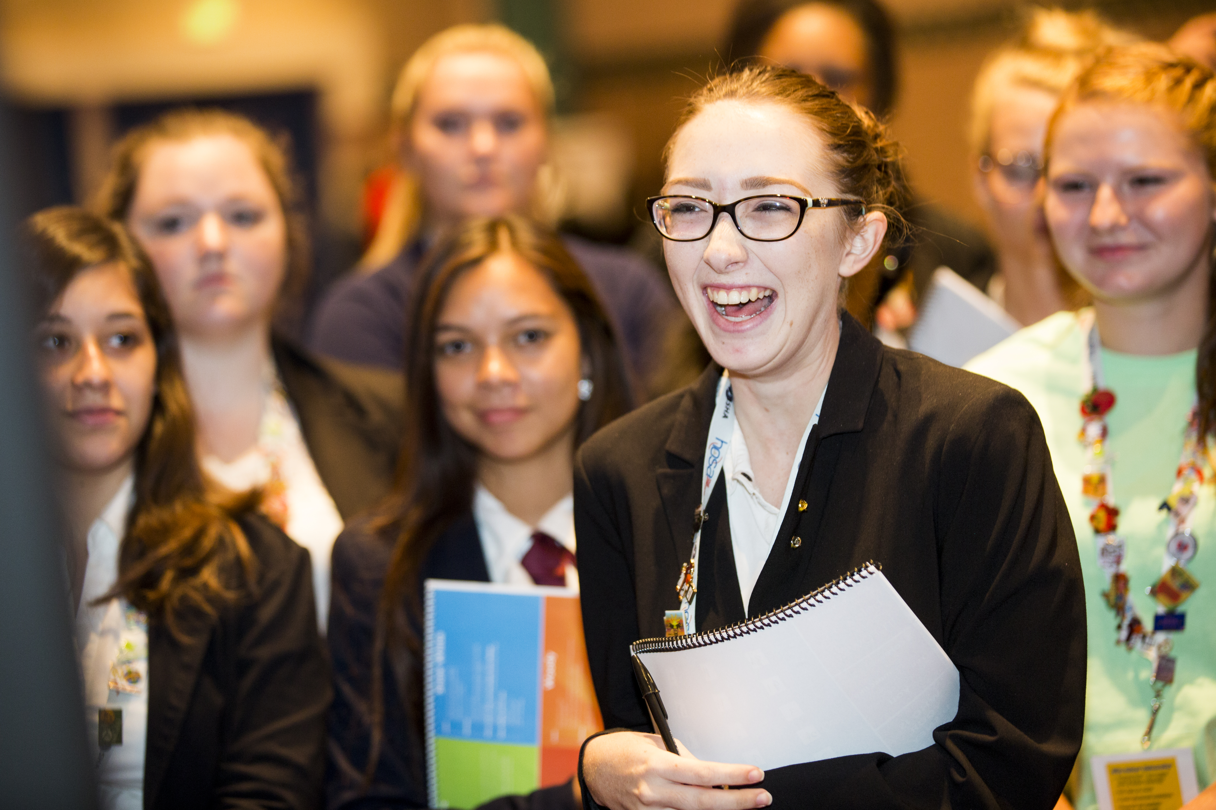

Public Relations
- Twitter
- Facebook
- Instagram
- Pinterest
- YouTube
- Brochure
- Corporate Sponsors
- Skyalerts – calls by school to parents
- Video of program on school website
- Activities in community health fairs
- Speaking to high schools & middle schools about HOSA
- Local news
- School electronic billboards
- Virtual newsletters for the chapter, area
- Pep Rallies
- Press Releases
- Legislative Day
- Write articles for HOSA & Department of Education newsletters, school district newsletters
- Traditional
  - TV
  - Radio
  - Billboards
  - Bulletin Boards
  - Posters in School
- School TV
- Advisory Committees
- Website
- Eighth grade tours
- Speaking events
  - Chamber of Commerce
  - School Boards
  - Hospital Association
  - Community Foundations
  - Lion’s Club
  - Kiwanis
- Flyers
- Post-Cards/Mailers
- Word of Mouth
- Invite legislators to classroom/events
- HOSA Week!!
- Advisory Committees
- Posters for Community projects
- Booth at local festivals
- Blood Drives
- School College Day involvement
- Presentation to PTA
- Open House
- Tables at local high schools that feed into our program
- Presentations to middle school students
- T-shirts
- Local hospital/healthcare facility ambassador program

Employment
- Internships
- Partnerships
- Certifications
- Job Shadow
- Co-ops
- Collaboration with local community colleges and universities
- Job Interviewing Skills
- Volunteering
- Soft Skill Development
- Resumes
- Mock interviews
- Industry Tours
- Connecting with community health organizations
- Portfolios
- Reference Letters
- College Application help
- Career Research paper
- College Fairs
- Career Fairs
- Competitions
- Job Board on website
- Utilizing alumni as speakers and mentors
- Guest Speakers
- Hospital/Healthcare Human Relations guest speaker

Professional Development
- Guest Speakers
- Seminars
- Webinars
- Chapter Officer Training
- Team Building Activities
- Resumes
- Etiquette
- Professional Dress Days
- College Days – have former students come back for a panel discussion
- Leadership Training with other CTSO Officers
- Educational Symposium Attendance
- Train
- College Visits
- Healthcare Trainings – i.e. Nutrition
- CPR/First Aid Training
- Weekly business meetings in classroom
- First impressions training (greeting, handshake, cell phone etiquette)
- Dress for Success
- Elevator Speeches
- Social Network Etiquette
- E-mail Etiquette
- Personal Statement Workshop
- Conflict resolution workshop
- Student presentation on careers (Health Career Display)
- Cadaver Lab visits
- Career panels
- Job Shadows
- Healthy Lifestyles presentation/portfolio project
- FISH training
- APA writing workshops
- Wellness initiatives
- Attending Body Worlds exhibit
- Connecting with Natural History Museum, Medical History Museum

