COMPETITION THROUGH HOSA
A Positive Viewpoint

Competition is inherent in society. HOSA members throughout their future lives will be involved in many forms of organized or incidental competition for jobs, advancement, leadership roles, and numerous other forms of recognition.

  - The HOSA Competitive Events Program is designed to foster a positive attitude toward competition.
  - Each event is competency based.
  - Each event focuses on one’s own ability to perform.
  - Achievement is measured against standardized criteria.

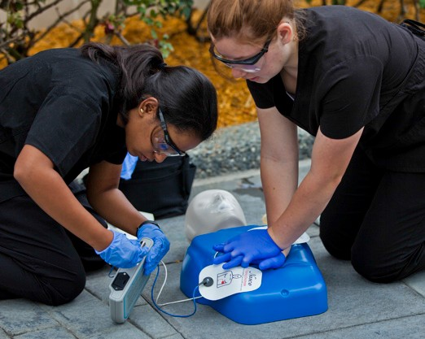
It is important for advisors to understand and stress the positive benefits of student participation in the HOSA Competitive Events Program. This provides an opportunity for students to strengthen knowledge, improve skills, and develop leadership ability. Self- confidence and courage are benefits of healthy competition. The ability to strengthen interpersonal relationships and to accept with grace both success and defeat are characteristics of the leaders of tomorrow.

HOSA members should be encouraged to analyze their own ability in the process of deciding where their interest and talents lie and in choosing to enter competition.
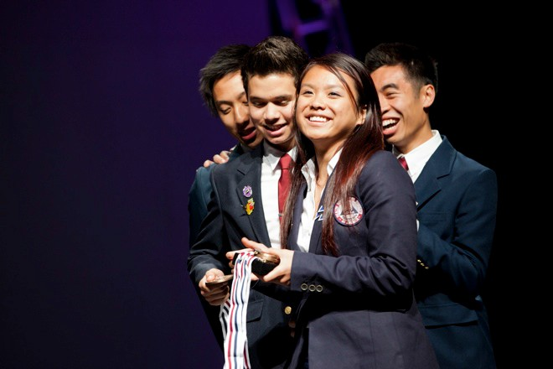
HOSA members, with the assistance of their advisor, should plan for competition within their chapter. Involvement of the health science education advisory committee members and other professionals in the community fosters public relations, improves skills, maintains standards, and helps the Chapter members to decide who should represent them at the state and national levels.

Preparation for participation in any of the HOSA Competitive Events should evolve as part of the natural, planned flow of the instructional process. HOSA Competitive Event Guidelines are instructional tasks and they should be used as any other teaching resource. They are especially useful as checklists or skills profiles to introduce, reinforce, and assess achievement of competency criteria in student performance of scheduled tasks (i.e. selected job skills, such as in the Dental Science Competitive Event, or for class and/or community presentations, as in the Prepared Speaking Competitive Event). Perhaps it is most important to recognize that competitive events do not govern instruction, but are supportive tasks to enhance instruction
Health Professions Events | Health Science  Events | Emergency Preparedness Events
Biomedical Laboratory Science  Clinical Nursing  Clinical Specialty  Dental Science  Home Health Aide  Medical Assisting  Nursing Assisting  Personal Care  Physical Therapy  Sports Medicine  Veterinary Science | Dental Terminology  Medical Spelling  Medical Terminology  Medical Math  Medical Reading  KT: Human Growth & Development  KT: Nutrition  KT: Medical Law & Ethics  KT: Pathophysiology  KT: Pharmacology  KT: Behavioral Health  KT: Transcultural Health Care | CPR/First Aid  Emergency Medical Technician  Epidemiology  Life Support Skills  MRC Partnership  CERT Skills  Public Health

Leadership  Events | Teamwork Events | Recognition Events
Extemporaneous Health Poster  Health Career Photography  Extemporaneous Writing  Healthy Lifestyle  Job Seeking Skills  Prepared Speaking  Researched Persuasive Writing and Speaking  Interviewing Skills  Speaking Skills | Community Awareness  Creative Problem Solving  HOSA Bowl  Parliamentary Procedure  Biomedical Debate  Health Career Display  Health Education  Forensic Medicine  Public Service Announcement  Medical Innovation: Existing  Medical Innovation: Original | Outstanding HOSA Chapter  Health Care Issues Exam  Outstanding State Leader  MRC Volunteer Recognition  National Service Project  Barbara James Service Award  HOSA Happenings

