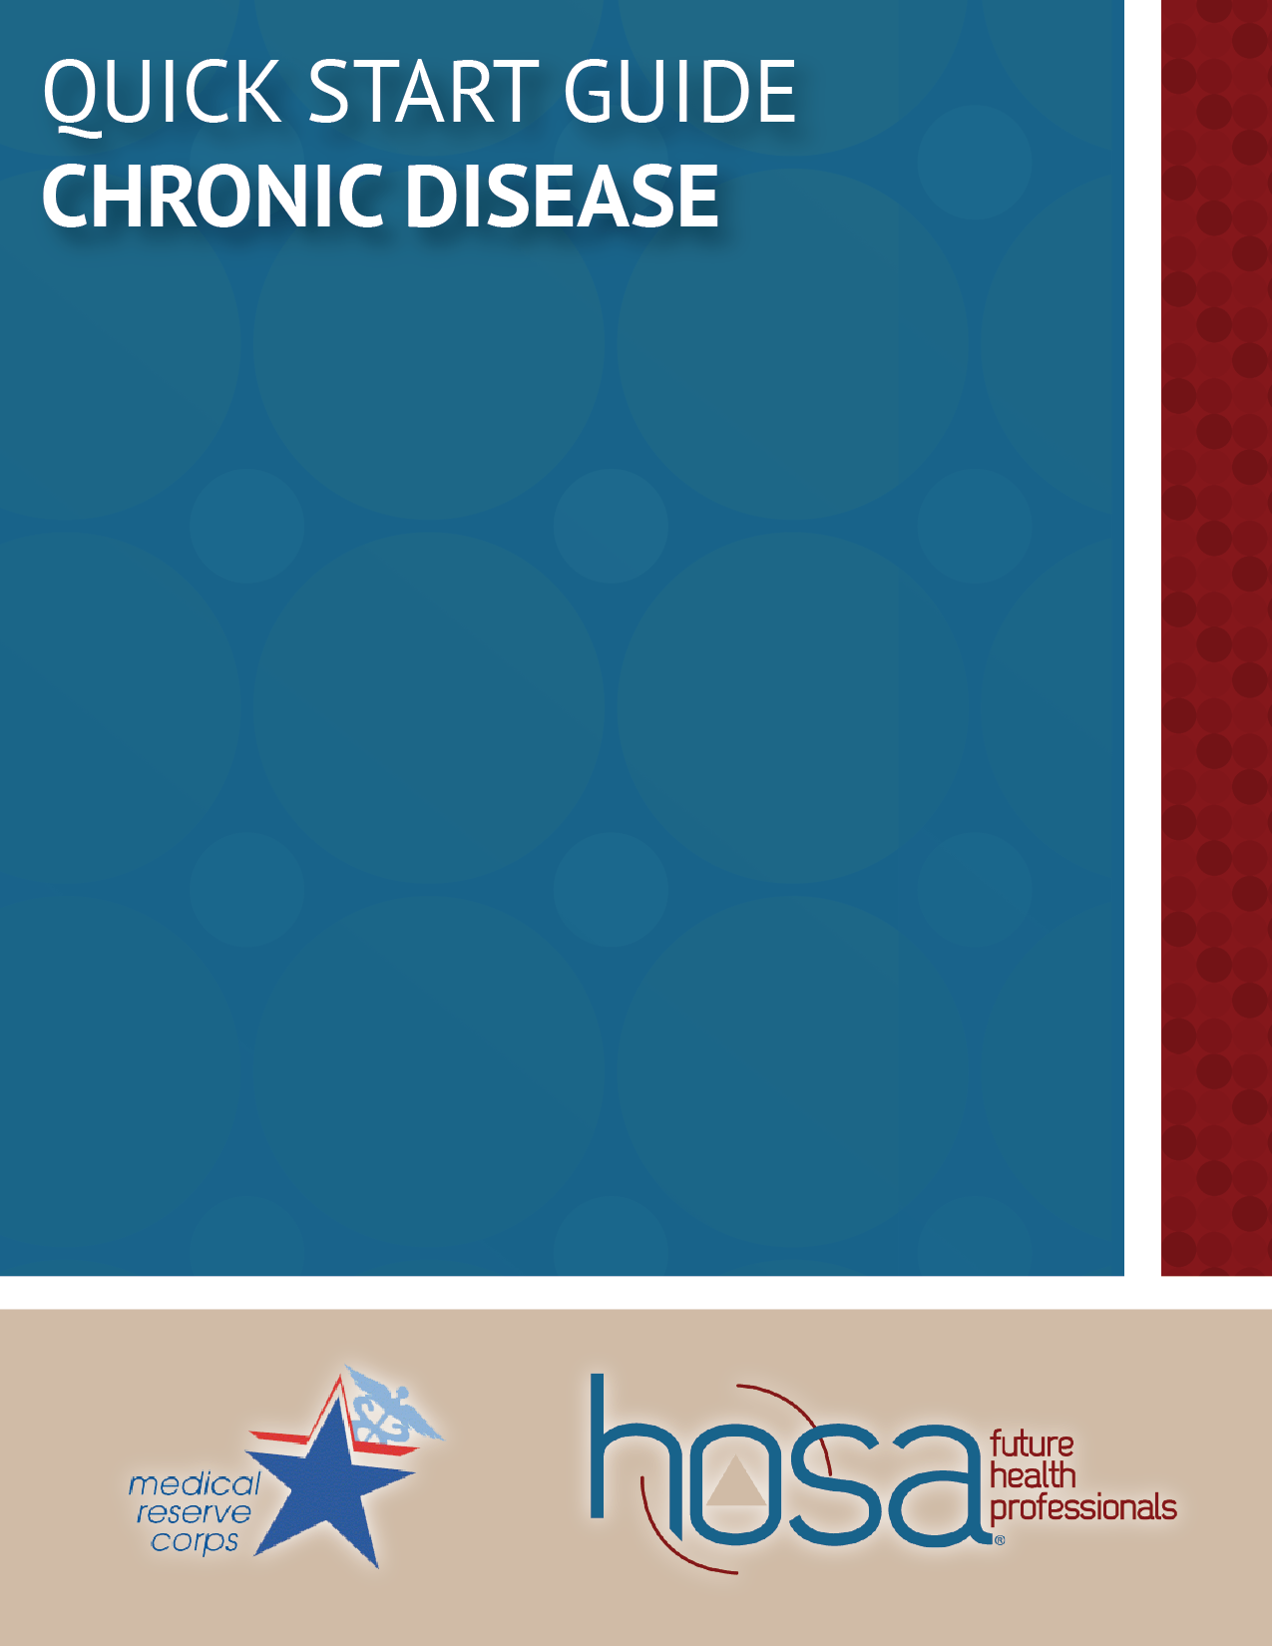

Contents

Introduction 3
Overview

Chronic Diseases 3-4
Heart Disease and Stroke
Obesity
Diabetes
Cancer
Arthritis

Common Causes 5
Lack of Physical Activity
Poor Nutrition
Tobacco Use
Excessive Alcohol Consumption

How to Get Involved 6
National Organizations
Local Actions

Sample Activities 6
Red Out
Walking Group

Introduction

Overview
Chronic diseases are among the most common, costly, and preventable of all health problems in the United States. These diseases include, heart disease, stroke, cancer, diabetes, arthritis, and obesity. All of these illnesses have significant health implications for the individuals suffering from them and can affect whole communities in a variety of ways. These diseases are generally preventable by changes to health behaviors and community health environments. Making these changes, however, are not simple. In the United States, seven out of ten deaths each year are caused by chronic disease. These diseases have some common four causes that contribute to differing aspects of a poor lifestyle: lack of physical activity, poor nutrition, tobacco use, and excessive alcohol consumption. Lowering chronic diseases would mean significantly changing these health behaviors.

Chronic disease has become one of the hardest-hitting forms of disease in the United States, and many deaths by chronic disease are preventable. Although it is not at the will or duty of communities to change people, there is a community aspect that is important in tackling these illnesses. Become an advocate in your community and promote preventive health care as well as positive changes to the health environment in your community

You can get involved in chronic disease care for your community by raising awareness in your community about these diseases and encouraging preventative measures. You can get involved in chronic disease care for your family by leading by example by maintaining and encouraging a healthy lifestyle. You can take charge of your own chronic disease care by knowing your health and living a healthy lifestyle to keep yourself healthy and happy.

Chronic Diseases

Heart Disease and Stroke
The term “heart disease” can be used to identify various types of heart conditions, but in the United States it is generally used to refer to coronary heart disease, the most common type in the US causing heart attacks, heart failure, and arrhythmias and killing more than 385,000 people annually. In the United States, heart disease is the leading cause of death for people of most ethnicities, with many minority groups being over-represented in the data. Many of these deaths, however, are preventable, as changes in health habits, improvements in community living spaces, and management of high blood pressure, high cholesterol, and diabetes could have prevented the death. Persons who have had coronary heart disease, a heart attack, or stroke report having an average of ten overall unhealthy days per month, which is five more than persons not experiencing one of those conditions.

Obesity
Overweight and obese are both terms to describe ranges of weight that are greater than what is generally considered healthy for a given height. This weight range is shown to increase the likelihood of certain disease and health problems, such as heart disease, stroke, type-2 diabetes, and certain types of cancer, which are some of the leading causes of preventable death. Currently, obesity is a major health concern, with one in every three adults being obese and almost every one in five youth between the ages of six and nineteen.

Diabetes
Diabetes refers to a group of diseases that are characterized by high blood glucose (blood sugar) due to the individual being unable to produce or use the insulin produced effectively to regulate blood sugar. This can lead to the buildup of glucose in the blood, causing diabetes as well as other serious health complications if not controlled. Diabetes is a major cause of heart disease and stroke in addition to potentially leading to other complications such as vision loss, kidney failure, and amputations of legs or feet, being the leading cause of these negative health outcomes in adults ages 20 to 74. Additionally, the risk of death for a person with diabetes is twice that of a person of similar age without diabetes.

Cancer
Cancer is a term used to describe a disease in which abnormal cells divide out of control, an occurrence that can become invasive to the body, leading to other issues. Cancerous cells can spread through the body by way of the blood and lymph systems, causing a variety of different types of cancers. There are more than one hundred different types of cancers, with some being more common than others. Breast cancer and prostate cancers are two of the most common cancers. Prevention is the best way to fight cancer, which means getting people to do things to protect their health, such as getting screened, quitting smoking, and exercising more. Cancer takes a toll on whole communities, as it spreads throughout the United States affecting each city, town, and neighborhood differently. For this reason, it is important to have communities united and led by local leaders in support of cancer prevention.

Arthritis
Although the term itself refers to joint inflammation, arthritis is a grouping of rheumatic disease and conditions that affect joints, tissue surrounding the joints, and other connective tissue. There are variations in the manifestation of arthritis, with pattern, severity, and location of symptoms depending on the form of the disease, but typical symptoms include pain and stiffness in and around one or more joints, developing gradually or suddenly. Arthritis is the most common cause of disability in the United States, with nearly 19 million Americans reporting activity limitations as a result of it.

Common Causes

Lack of Physical Activity
Engaging in physical activity is one of the most important aspects of maintaining a healthy lifestyle to prevent chronic diseases. Based on the 2008 Physical Activity Guidelines for Americans, more than one-third of all adults do not meet recommendations for aerobic physical activity and 23% reported no leisure-time physical activity at all in the preceding month.

Poor Nutrition
As another component of healthy living, obtaining the proper nutrients is crucial. This includes having a well-balanced diet consisting of the major food groups: protein, grains, fruits, vegetables, and dairy. However, in a 2007 survey less than 22% of high school students and only 24% of adults reported eating 5 or more servings of fruit or vegetables per day.

Tobacco Use
More than 43 million American adults smoke. In addition, 20% of high school students identify as current cigarette smokers according to a 2007 survey. Lung cancer is the leading cause of cancer death, and cigarette smoking causes almost all cases, with male smokers being 23 times more likely to develop lung cancer than nonsmokers. An estimated 443,000 deaths per year can be attributed to cigarette smoking.

Excessive Alcohol Consumption
Excessive alcohol consumption is the third leading preventable death in the United States, behind diet and physical activity and tobacco, contributing to over 54 different disease and injuries, including various cancers, liver disease, cardiovascular issues, and psychiatric problems. Binge drinking is identified as the most dangerous type of drinking and is reported by 17% of US adults.

How to Get Involved

- National Organizations
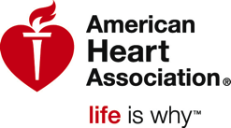
  - American Diabetes Association (diabetes.org)
  - American Heart Association (heart.org)
  - American Cancer Society (cancer.org)
  - Arthritis Foundation (arthritis.org)
  - Americans for Nonsmokers’ Rights (no-smoke.org)
  - PreventObesity.net (preventobesity.net)
- Local Actions
  - Volunteer at an after-school program to promote physical activity
  - Teach healthy cooking classes
  - Participate in a local Relay for Life cancer fundraiser (relayforlife.org)

Sample Activities

“Red Out”
“Red Out”: For February, heart health month, have a “red out” at the school basketball game. Sell t-shirts and special gear for game day to raise money for cardiovascular research. On game day, tape up flyers with different heart health facts on them around the arena!

Walking Group
Start a walking group that meets every week. Advertise via social media and/or postnig flyers around the community, then make sure someone from your chapter is at the starting point every week. Healthy habits lead to a healthy heart!

